DBMS Lab, CSE 312 Assignment – 01

Name: Rashidul Hasan Hridoy

ID: 171 – 15 – 8596

Section: E

1.

SQL> Create table Malaysia(

2 SID int,

3 FName varchar(255),

4 LName varchar(255),

5 Age int,

6 Grade number(3, 2),

7 PhoneNumber varchar(255));

Table created.

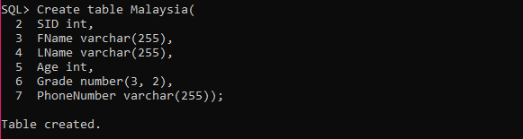

SQL> INSERT ALL

2 INTO Malaysia(SID, FName, LName, Age, Grade, PhoneNUmber) VALUES (1, 'Ovi', 'Majumdar', 22, 1.25, 0123)

3 INTO Malaysia(SID, FName, LName, Age, Grade, PhoneNUmber) VALUES (2, 'Akash', 'Phatan', 21, 2.22, 6541)

4 INTO Malaysia(SID, FName, LName, Age, Grade, PhoneNUmber) VALUES (3, 'Raja', 'Tushar', 24, NULL,6548)

5 INTO Malaysia(SID, FName, LName, Age, Grade, PhoneNUmber) VALUES (4, 'Nusrat', 'Jahan', 26, 1.21, 1324)

6 INTO Malaysia(SID, FName, LName, Age, Grade, PhoneNUmber) VALUES (5, 'Rubaiya', 'Hafiz', 24, 0.88, 9546)

7 INTO Malaysia(SID, FName, LName, Age, Grade, PhoneNUmber) VALUES (6, 'Sazzad', NULL, 28, 4.00, 3598)

8 INTO Malaysia(SID, FName, LName, Age, Grade, PhoneNUmber) VALUES (7, 'Nag', 'Pinku', 30, 0.25, NULL)

9 SELECT \* FROM dual;

7 rows created.

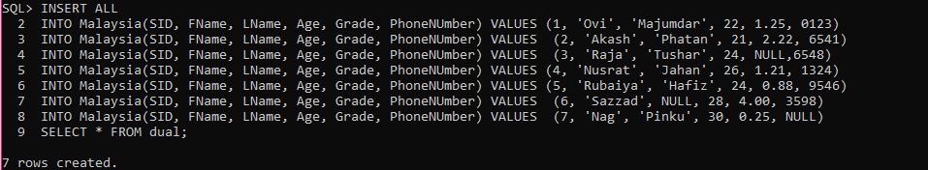

SQL> select \* from Malaysia;

2.

UPDATE Malaysia

SET grade = 2.25

WHERE SID = 3;

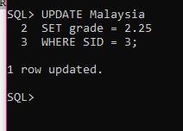

UPDATE Malaysia

SET LName = 'Hossian'

WHERE SID = 6;

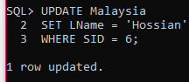

UPDATE Malaysia

SET PhoneNUmber = 12345

WHERE SID = 7;

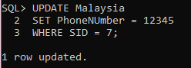

ALTER TABLE Malaysia MODIFY SID INT NOT NULL;

TABLE altered.

SQL> ALTER TABLE Malaysia MODIFY SID INT NOT NULL;

TABLE altered.

SQL> ALTER TABLE Malaysia MODIFY FName VARCHAR(255) NOT NULL;

TABLE altered.

SQL> ALTER TABLE Malaysia MODIFY LName VARCHAR(255) NOT NULL;

TABLE altered.

SQL> ALTER TABLE Malaysia MODIFY Age INT NOT NULL;

TABLE altered.

SQL> ALTER TABLE Malaysia MODIFY Grade NUMBER(3,2) NOT NULL;

TABLE altered.

SQL> ALTER TABLE Malaysia MODIFY PhoneNumber varchar(255) NOT NULL;

TABLE altered.

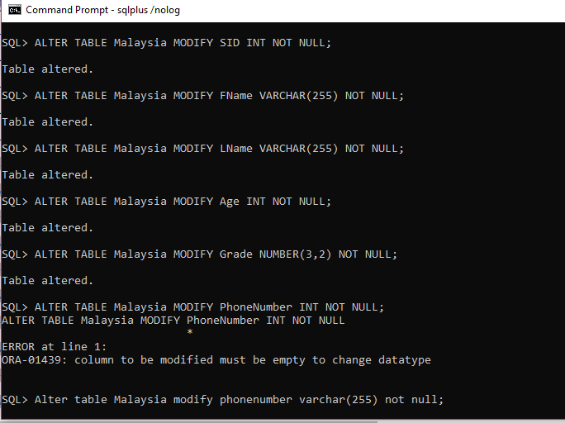

SQL> desc Malaysia;

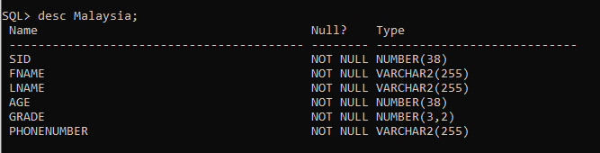

3.

Uniqe means in there will be no duplicate valus and Not Null means null values can’t be soted in database. Uniqe don’t allow duplicate values but not null allow it.

4.

SQL> delete from Malaysia where FName = 'Ovi' or LName = 'Ovi' or FName = 'Nag' or LName = 'Nag';



5.

SQL> delete from Malaysia;

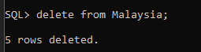

6.

SQL> Drop Table Malaysia;



7.

Constraints are used to make sure that the integrity of data is maintained in the database. I know about five constraint, one of them is not null. It ensures that a column cannot have NULL value.

8.

QL> select FName, Age from Malaysia where grade = 1.12 or grade > 1.12;

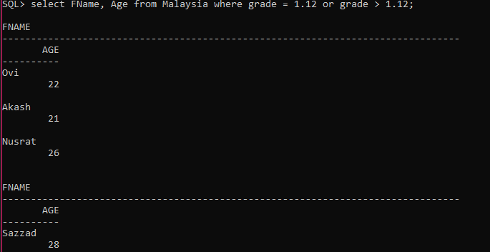

9.

SQL> select \* from Malaysia where FName like 'R%';

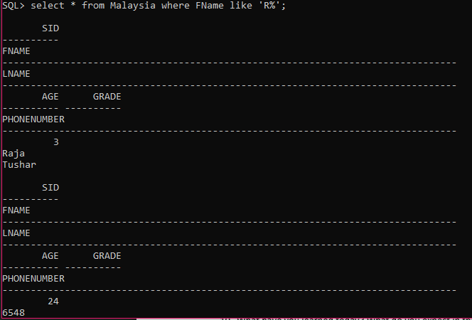

10.

I have learned today how to create a table, how to insert values, how to show vales, how to update column null to not null, how to update values, how to delete a row , how to delete a table data, how to delete a table, how to select data from table using condition.